**Supplementary Materials for**

**Step-by-step integration of multimodal data from liquid-based biopsy improves the predictive performance of lipid accumulation in the liver of mice.**

Martin David, Monbet Valérie, Leroyer Patricia, Oliviero Nolwenn, Turlin Bruno, Salim Zerrouki, Fautrel Alain, Ropert Martine, Sire Olivier, Loréal Olivier.

David.martin.2@univ-rennes.fr

**This PDF file includes:**

Figures S1 to S4

Table S1

CTL

HFHC

IRON

IRON + HFHC

Sirius Red

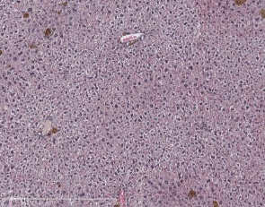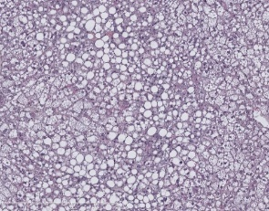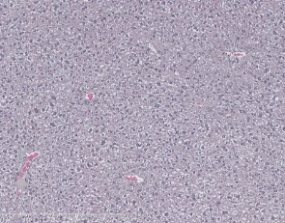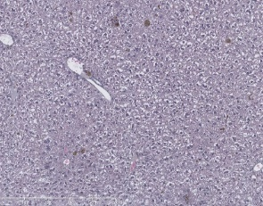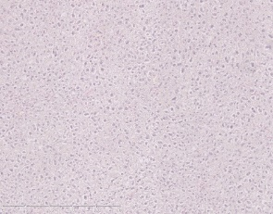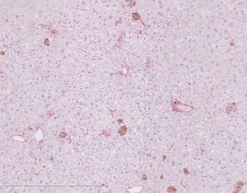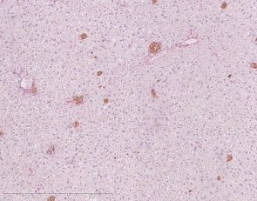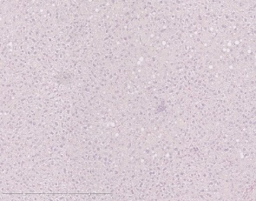

HES

**Figure S1. Liver staining.** HES and Sirius Red staining of the liver of CTL, HFHC, IRON, and IRON/HFHC mice at 22 weeks. The scale bar corresponds to 500µm. Black arrows are related to collagen.

|  |  |  |
| --- | --- | --- |
| 5’ -3’ | Fwd | Re |
| *A2m* | GAAACAGAGATCAGCATGACCAGTA | CATTTGGATTTGTGGTAGAGGAACT |
| *Crp* | TGGTGGGAGACATCGGAGAT | GCCCGCCAGTTCAAAACAT |
| *Hprt1* | CCGGAATCCCTATCTTTAGTCC | GGGTCAGTCCAGTGCCATAAG |
| *Nrf2* | CGAGATATACGCAGGAGAGGTAAGA | GCTCGACAATGTTCTCCAGCTT |

**Table S1.** **Primers used for liver tissue.** *Crp,* C - reactive protein; *Hprt1*, hypoxanthine phosphoribosyltransferase 1; *Nrf2*, Nuclear factor (erythroid-derived 2)-like 2; *A2m*, α2-macroglobuline